Write about the design of a system that you might build for your home which uses an Arduino with a Wi-Fi shield. The system must use the Wi-Fi connection for a useful purpose in the system. The Arduino should be wired to sensors and/or actuators which help it to perform some useful task in your home.

Be sure to clearly describe the need for the Wi-Fi connection in your system.

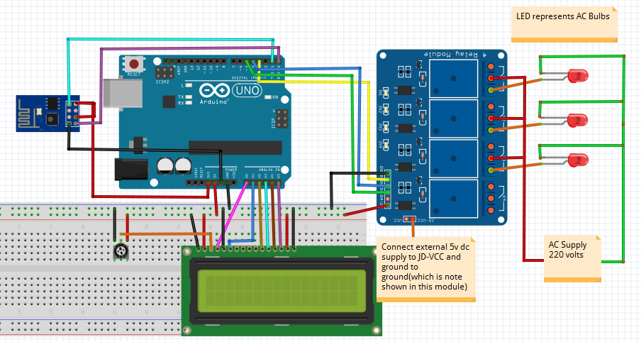

The system I want to build for my home is “**Home automation system**”. In this system I want to include temperature sensor, humidity sensor, PIR sensor, Arduino and Arduino Wi-Fi shield and also some relays.

The main aim of my project is to make my home a smart home by controlling appliances of my house using sensors and control them wirelessly using a mobile phone. I also want to add google assistant to this project to control seamlessly.

Some features of my project are:

1) Turn the light ON and OFF using PIR sensor and share the status of the light online continuously.

2) Control the Air Conditioner using a relay according to sensors and reflect the sensor values using the Wi-Fi Client.

3) Control some home appliances like fan and light irrespective of values of sensors.

I saw some YouTube videos regarding this, and I will surely implement this in future.